cnc_deltlifedt

声明
/* delete tool life management data(tool data) */
[DllImport("FWLIB32.dll", EntryPoint = "cnc_deltlifedt")]
public static extern short cnc_deltlifedt(ushort FlibHndl, short a, short b);

描述
删除刀具数据。
Deletes the tool data. When the tool data is deleted, all subsequent tool data is shifted up to fill the deleted space, as shown below.
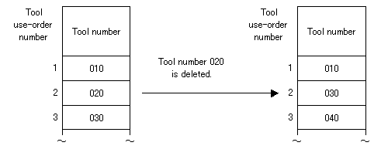

参数
(1)库句柄；
(2)short a设定刀组号；[in]
(3)short b设定刀具使用顺序号；[in]

函数返回值

代码
class Program
{
static void Main(string[] args)
{
ushort Flibhndl = 0;

short ret; // 返回值

// 获取库句柄 ( Ethernet )
ret = Focas1.cnc_allclibhndl3("192.168.0.224", 8193, 10, out Flibhndl);
if (ret != Focas1.EW_OK)
{
Console.WriteLine("发生异常，请检查！");
return;
}

#region cnc_deltlifedt

string _grp_num = Console.ReadLine();
string _ent_num = Console.ReadLine();
short grpno_s = short.Parse(_grp_num);
short grpno_e = short.Parse(_ent_num);

ret = Focas1.cnc_deltlifedt(Flibhndl, grpno_s, grpno_e);

#endregion
}
}

